Open Geospatial Consortium
Date: 2012-07-11
External identifier of this OGC® document: <http://www.opengis.net/doc/template/standard/1.0>
Internal reference number of this OGC® document: 12-nnnr1
Version: 0.2.0
Category: OGC® Best Practice
Editor: <Name(s) of Editor or Editors>

OGC
Meteorology & Oceanography Domain Working Group
WMS 1.3 Best Practice

Copyright notice
Copyright © 2012 Open Geospatial Consortium
To obtain additional rights of use, visit http://www.opengeospatial.org/legal/.

Warning
This document is not an OGC Standard. It is distributed for review and comment. It is subject to change without notice and may not be referred to as an OGC Standard.
Recipients of this document are invited to submit, with their comments, notification of any relevant patent rights of which they are aware and to provide supporting documentation.
Document type: OGC® <Publicly Available Best Practice
Document subtype: <interface, encoding, application profile, profile>
Document stage: Draft
Document language: English

- Abstract
This document proposes a set of Best Practices and some guidelines for implementing and using the OGC Web Map Service version 1.3 implementation specification. In particular, restrictions on the use of WMS1.3 are defined to allow unambiguous and safe interoperability between clients and servers, both in the context of expert meteorological and oceanographic usage and in other communities using meteorological and oceanographic information in conjunction with their own domains’ data.
Where strict normative conformance has been identified, this is indicated, with reference to the original standard.
- Keywords
The following are keywords to be used by search engines and document catalogues:
ogcdoc, WMS, 1.3, map web service, meteorology, oceanography, time, elevation.
- Preface
Attention is drawn to the possibility that some of the elements of this document may be the subject of patent rights. The Open Geospatial Consortium shall not be held responsible for identifying any or all such patent rights.
Recipients of this document are requested to submit, with their comments, notification of any relevant patent claims or other intellectual property rights of which they may be aware that might be infringed by any implementation of the standard set forth in this document, and to provide supporting documentation when possible.
- Submitting organizations
The following organizations submitted this Document to the Open Geospatial Consortium Inc.
DWD (Deutscher Wetterdienst)
ECMWF (European Centre for Medium-range Weather Forecasts)
Météo-France
Technische Universität Dresden
UK Met Office
USA NOAA
US Navy
- Submitters
All questions regarding this submission should be directed to the editor or the submitters:
Name | Company
Chris Little | UK Met Office
Marie-Françoise Voidrot-Martinez | Météo-France
Jeff de La Beaujardière | NOAA

Introduction
The meteorological and oceanographic communities have been exchanging information internationally for at least 150 years and very well understand the importance of geospatial interoperability standards encompassing standardized data formats, interfaces, processes; shared conceptual models and stable, sustainable, maintenance processes and institutions.
Because of the demanding nature of meteorological and oceanographic data processing, the communities have evolved domain specific solutions. As computers have become more powerful, it has become feasible to use general geospatial software for day-to-day operational purposes, and interoperability problems have arisen. There is also an increasing need to combine meteorological and oceanographic with other forms of geospatial data from other domains, in ways convenient for those domains.
This document describes and justifies a set of Best Practices for implementing Web Map Service (WMS) servers and clients to meet the interoperability requirements of the meteorological and oceanographic communities and to allow the economies of using Commercial Off The Shelf geospatial software.

Scope
This document specifically addresses the existing WMS Version 1.3 standard and implementations.
The possibility of re-using these Best Practices for future versions of WMS and other OGC standards is/could be also considered.
A WMS server produces maps of spatially referenced data dynamically from geographic information where a “map” is a portrayal of geographic information as a digital image suitable for display on a computer screen. A map is not the data itself. WMS produced maps are generally rendered in a pictorial format such as PNG, GIF or JPEG, or occasionally as vector-based graphical elements in Scalable Vector Graphics (SVG) or Web Computer Graphics Metafile (WebCGM) formats.

WMS defines three operations:
- one returns service-level metadata;
- another returns a map with well-defined geographic and dimensional parameters;
- an optional operation returns information about particular features shown on a map.
WMS operations can be invoked using a standard web browser by submitting requests in the form of Uniform Resource Locators (URLs). The content of such URLs depends on which operation is requested. In particular, when requesting a map, the URL indicates what information is to be shown on the map, what portion of the Earth is to be mapped, the desired coordinate reference system, and the output image width and height. When two or more maps are produced with the same geographic parameters and output size, the results can be accurately overlaid to produce a composite map. The use of image formats that support transparent backgrounds (e.g. GIF or PNG) allows underlying maps to be visible. Furthermore, individual maps can be requested from different servers. The WMS thus enables the creation of a network of distributed map servers from which clients can build customized maps.
A basic WMS classifies its geographic information holdings into “Layers” and offers a finite number of predefined “Styles” in which to display those layers. This Best Practice assumes that WMS supports only named Layers and Styles, and does not include a mechanism for user-defined symbolization of feature data.
The teleconf of the 2012-05-14 agreed on encompassing Time and Elevation into the first release of Best Practices.

WMS 1.3 (Annex C) allows dimensional axes in Capabilities XML
  - TIME : <Dimension name="time">
    - GetMap request includes TIME=T
  - ELEVATION: <Dimension name="elevation">
    - GetMap request includes ELEVATION=Z
  - Provider-defined "sample dimensions": <Dimension name="something">
    - GetMap request includes DIM_something=value

Aim
- Seeking agreement on how to list available values on each axis
  - Goal: Provide enough info to allow user choice
  - Use METADATA_URL to provide a link to an ISO 19139 compliant metadata record for the layer
- This (draft) Best Practice covers:
  - Server (Capabilities XML) and client (GetMap request) rules
  - simple cases (e.g., 0 or 1 time axis)
  - multiple overlapping time axes
  - data values on computed surfaces
TIME
Temporal Axes in WMS: General Rules
- WMS 1.3 specification requirements for all cases:
  - Time shall be normally be expressed in ISO 8601 format
    - ccyy-mm-ddThh:mm:ss.sssZ, to appropriate precision
    - Required attribute: units="ISO8601“
    - This includes the time zone
  - Climatological intervals and temporal references will be the subject of future work and may not use strict ISO 8601.
  - Multiple times may be expressed either as a list or as a start/end/interval, as shown in WMS 1.3 Table C.2.
- Met/Ocean DWG Best Practices:
  - <Dimension name="time"> always applies to validity time (of observation or forecast)
  - Express each map as a single Layer with 0+ temporal axes
    - Avoid multiple independent layers with time encoded in Layer Name.

Case 1 : WMS Layer with no defined Time
- Examples:
  - Topographic base layer
  - Layers for climatological normals* (e.g. Standard Normals of maximum temperature in Germany for the period between 1961 and 1990)
- Server:
  - Do not declare a TIME value for this layer
  - Avoid inheritance of TIME from parent layers
- Client:
  - TIME may be included in GetMap request
  - TIME in GetMap request is ignored for this layer
* WMO defines normals as "period averages computed for a uniform and relatively long period comprising at least three consecutive 10-year periods".

Case 2 : WMS Layer with single Time axis
- Example:
  - Layer with one or more available times along a single Time axis
- Server:
  - TIME axis states time values {Ti}
    - List (T0, T1,... TN) and/or range (T0/T1/ΔT) [see WMS Table C.2]
  - Recommended attributes:
    - current=TRUE (if data are continually updated)
    - default=Tdefault (what time will be sent if client does not specify)
    - nearestValue=TRUE (nearest available time will be sent)
  - Optional attributes:
    - multipleValues=TRUE (if allow multiple times in one request)
      - Result is animation or mash-up of multiple times
- Client:
  - TIME is recommended in GetMap request
  - Decision tree on next slide

Case 3: WMS Layer with double Time axis
- Use case 1: Numerical model Outputs
  - A weather forecast model is initialized and run every 6 hours and produces a 5-day forecast with a temporal resolution of 3 hours. There are multiple forecasts for each 3hr interval.
- Use case 2:
  - A warning is associated with several time information. The CAP standard (CAP = Common Alert Protocol) defines 4 time attributes:
    - Sent: The time and date of the origination of the warning (Mandatory)
    - Effective: The effective time of the information of the warning
    - Onset: The expected time of the beginning of the subject event of the warning
    - Expires: The expiry time of the information of the warning
  - In several CAP implementations for met warnings, sent time is equal to effective time
  - The validity time is the period between „onset“ and „expires“.
  - If CAP files with meteorological warnings are produced periodically (e.g. every 5 minutes), then a warning may exist in more than one CAP file.
  - The sent time can be used to distinguish them via a dimension.
- Use case 3:
  - A trajectory is the path that a moving object follows through space as a function of time. In meteorology trajectories are often computed periodically. Then you have a set of trajectories with different starting times.
  - The start time can be used to distinguish them via a dimension
- Server:
  - <Dimension name=“time"> : validity times
  - <Dimension name=“reference_time"> shall be used for forecasts analysis or initialisation time
  - <Dimension name=“reference_time"> may be used for other meanings if appropriate
  - Server may define additional time axes <something>_time for non-model data.
    - <Dimension name=“sent_time"> reference time for warnings
    - <Dimension name=“start_time"> reference time for trajectories
  - Sending a change request to update the Best Practices in parallel would be appreciated
- Client: TIME and DIM_XXX_TIME are recommended in GetMap request

ELEVATION

Conformance
This Standard defines XXXX.
Requirements for N standardization target types are considered:
- AAAA
- BBBB
Conformance with this standard shall be checked using all the relevant tests specified in Annex A (normative) of this document. The framework, concepts, and methodology for testing, and the criteria to be achieved to claim conformance are specified in the OGC Compliance Testing Policies and Procedures and the OGC Compliance Testing web site.
In order to conform to this OGC™ interface standard, a software implementation shall choose to implement:
- Any one of the conformance levels specified in Annex A (normative).
- Any one of the Distributed Computing Platform profiles specified in Annexes TBD through TBD (normative).
All requirements-classes and conformance-classes described in this document are owned by the standard identified as Error! Unknown document property name. .

References
The following normative documents contain provisions that, through reference in this text, constitute provisions of this document. For dated references, subsequent amendments to, or revisions of, any of these publications do not apply. For undated references, the latest edition of the normative document referred to applies.
OpenGIS® Web Map Server Implementation Specification Version 1.3.0.
Date 2006-03-15. http://portal.opengeospatial.org/files/?artifact_id=14416

ISO 8601:2004, Data elements and interchange formats — Information interchange — Representation of dates and times

Terms and Definitions
This document uses the terms defined in Sub-clause 5.3 of [OGC 06-121r8], which is based on the ISO/IEC Directives, Part 2, Rules for the structure and drafting of International Standards. In particular, the word “shall” (not “must”) is the verb form used to indicate a requirement to be strictly followed to conform to this standard.
For the purposes of this document, the following additional terms and definitions apply.
4.1
client
software component that can invoke an operation from a server
4.2
geographic information
information concerning phenomena implicitly or explicitly associated with a location relative to the Earth [ISO 19101]
4.3
interface
named set of operations that characterize the behaviour of an entity [ISO 19119]
4.4
layer
basic unit of geographic information that may be requested as a map from a server
4.5
map
portrayal of geographic information as a digital image file suitable for display on a computer screen
4.6
operation
specification of a transformation or query that an object may be called to execute [ISO 19119]
4.7
portrayal
presentation of information to humans [ISO 19117]
4.8
request
invocation of an operation by a client
4.9
response
result of an operation returned from a server to a client
4.10
server
a particular instance of a service
4.11
service
distinct part of the functionality that is provided by an entity through interfaces [ISO 14252]

Abbreviated terms
COTS Commercial Off The Shelf software
GIF Graphics Interchange Format
GIS Geographic Information System
JPEG Joint Photographic Experts Group
OGC Open GIS Consortium
PNG Portable Network Graphics
SVG Scalable Vector Graphics
URL Uniform Resource Locator
WebCGM Web Computer Graphics Metafile
WMS Web Map Service

Conventions
This sections provides details and examples for any conventions used in the document. Examples of conventions are symbols, abbreviations, use of XML schema, or special notes regarding how to read the document.

<Clauses not Containing Normative Material>
Paragraph

Clauses not containing normative material sub-clause 1
Paragraph

Clauses not containing normative material sub-clause 2
Paragraph

<Clauses containing normative material>
Paragraph

<Requirement Class A or Requirement A>
Paragraph – intro text. The following table is an example only. Modify as necessary.
Requirements Class
http://www.opengis.net/spec/ABCD/m.n/req/req-class-a
Target type | Token
Dependency | http://www.example.org/req/blah
Dependency | urn:iso:ts:iso:19139:clause:6
Requirement | http://www.opengis.net/spec/ABCD/m.n/req/req-class-a/req-name-1  requirement description
Requirement | http://www.opengis.net/spec/ABCD/m.n/req/req-class-a req-name-2  requirement description
Requirement | http://www.opengis.net/spec/ABCD/m.n/req/req-class-a /req-name-3  requirement description.

Requirement Class B or Requirement B

- <Example – remove from document> When a WCS server encounters an error while performing a GetCapabilities operation, the server shall return an exception report message as specified in Clause 8 of [OGC 06-121r8]. http://opengis.net/spec/WCS/2.0/core/exception.

Media Types for any data encoding(s)
A section describing the MIME-types to be used is mandatory for any standard involving data encodings. If no suitable MIME type exists in http://www.iana.org/assignments/media-types/index.html then this section may be used to define a new MIME type for registration with IANA.

Annex A: Conformance Class Abstract Test Suite (Normative)
  - Conformance class: AAAA (repeat as necessary)
<Example – remove from document>

Annex B: Revision history

Date | Release | Author | Paragraph modified | Description
2012-07-10 | 0.1.0 | CTL | All | First introductory text

Annex C: Bibliography
The bibliography may include
— documents that are not publicly available,
— documents to which only informative reference is made, and
— documents which have merely served as references in the preparation of the standard
Annex of Content from PowerPoint Slides Version 1.8.3
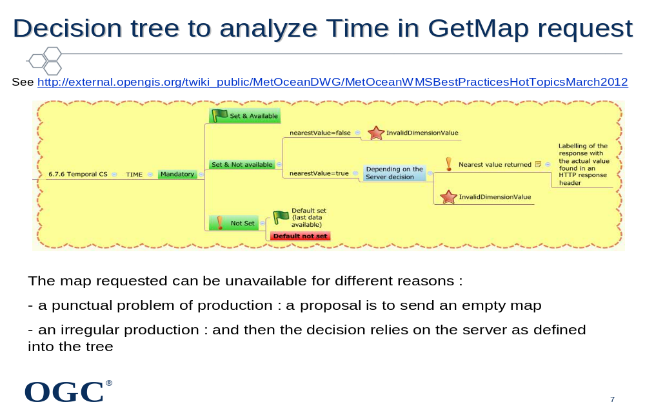
Discussions during teleconf 2012-04-23:
How should we define the nearest value ? Shouldn’t we define a new computation capacity to calculate the nearest value?
It is not possible to change WMS 1.3 but this could be submitted to WMS 2.0 DWG.
The Best practice should define a guidance : if the available time has a time reduction (monthly data as month means for instance) the precision of the time requested should be truncated at the month info then the nearest value should be calculated.

Discussions during teleconf 2012-05-14:
Martin Desruisseau has implemented several servers that define time has a period and not a time stamp in order to avoid to set nearest value:
the data is valid or not for the requested time

The time included into the request will be truncated to the significant precision to avoid having time stamps to precise that would require a non intuitive algorithm to select the answer.

Adrian 18-06-2012: Cool, a decision tree! However, needs to be more complete. The 'nearestValue' might not be set: is there a default value, is it server choice? If the parameter TIME is MANDATORY and then not present, you can't really return a default map---that makes the parameter optional. "in an HTTP response header" needs more work: what header, what happens when the client does not have access to that header?
Discussions during the teleconf 2012-04-23:
The name of Analysis_time is discussed again. This name comes from inputs from the Modelling activities. An email has been sent to Jeremy Tandy to check if changing this name could have some impacts on other connected works. No answer at the moment.
Other possibilities are discussed the aim being to make it more explicit:
- Run_time, Model_run_time, but the word « run » is only clear to people working in meteorology and even some of them call them cycles.
- Model_analysis_time,
- Initialisation_time
- starting_time
Has the name to be generic for other products than model outputs as forecast radar images, reanalysis model output?…
Frederic points out that:
- In CF conventions: forecast_reference_time.
- In WMO GRIB ed 2: In section 1 : "Reference Time » (bytes 13 to 19) plus "Significance of Reference Time » (byte 12) which is a code List (table 1.2):
0 : analysis
1 : start of forecast (?)
2 : verifying time of forecast
3 : observation time
- INSPIRE data models for many themes (at least meteorology and oceanography) are based on O&M, according to the "Guidelines for the use of Observations & Measurements and SWE- related standards in INSPIRE Annex II and III data specification development". The current version of this document (almost finalized ...) recommends to handle the model "run" both in the Observation (parameter : NamedValue), and the related Process (processParameter : ProcessParameter). At the moment, "AnalysisTime" is just mentioned as a possible value for the parameter name. (actually, an URL of a dictionary entry, ie http://inspire/processParameterValue.html#AnalysisTime).
So, the current INSPIRE Model for Atmospheric Conditions is quite flexible under this aspect (soft-typed). Nevertheless it is not the case for WMS dimensions, and the term of "AnalysisTime" already appears in informative sections of the INSPIRE AC-MF Specification v3.0 ( candidate version to be released by the end of May ).
Therefore, it would be better to harmonize the vocabulary as soon as possible.
Adrian 18-06-2012: Use case 1: I personally would separate different model runs in different layers since (1) it's practical from a data set point of view and (2) these runs differ in semantics at least of information used to generate the predictions but also possibly, periodically in the algorithms and hardware used.
Use case 2: This needs a clearer explanation of how it will work. A user is presumably looking at a weather map for a given date and time (using the TIME parameter). The 'warnings' layer would show any warnings applicable to that time period. I would expect the next step would be to getInfo about the 'warnings' layer at the locations where the warnings are drawn to get the other information *not* to change a parameter on the warning layer (i.e. give me the warnings applicable to this date and time but only issued recently). The latter could also be done with a Feature backed layer and a filter. But I am not sure I correctly understand the use case.
Discussions during the teleconf 2012-05-21 and 2012-05-28 – 2012-06-11:
There were a lot of discussions to decide if we could create a unique multi purpose « Reference_time » dimension covering several semantics.
The interest was making something simple , general and making the use more efficient as the client could make a request with a single « reference_time » for all layers.

Taking the use case of a client that would like to combine a model output (from a model that runs each 6 hours) and warnings (that are issued each 5 mn) valid for the same validity time, it is obvious that the same « reference_time » cannot be shared between the layers.
On another hand a single request combining dim_reference_time, dim_sent_time, and dim_start_time is possible if each dimension only applies for the relevant layers.

So the current proposal (2012-06-11) is:
(1) REFERENCE_TIME *shall* be used for model forecast analysis or initialization time;
(2) Server *may* define additional time axes <something>_TIME for non-model data.
Sending a change request to update the Best Practices in parallel would be appreciated
(3) REFERENCE_TIME *may* be used for other meanings if appropriate to a server that does not have model outputs but does have data for which reference time is an appropriate concept.

The possibility to define a dim_name as a URL as also been mentioned and enhanced by Peter Bauman
« Our approach, with the OGC Name Type Specification [1], is to introduce semantics by defining axis URLs so that we do not need to rely on nomenclature alone. It also allows to have synonyms (like elevation and height), national translations, etc.
We have proposed "t" and "time" for now, but this still can be influenced (such as adding "phenomenonTime" as a synonymous axis definition). Defining further, non-synonymous time dimensions can be done similarly.

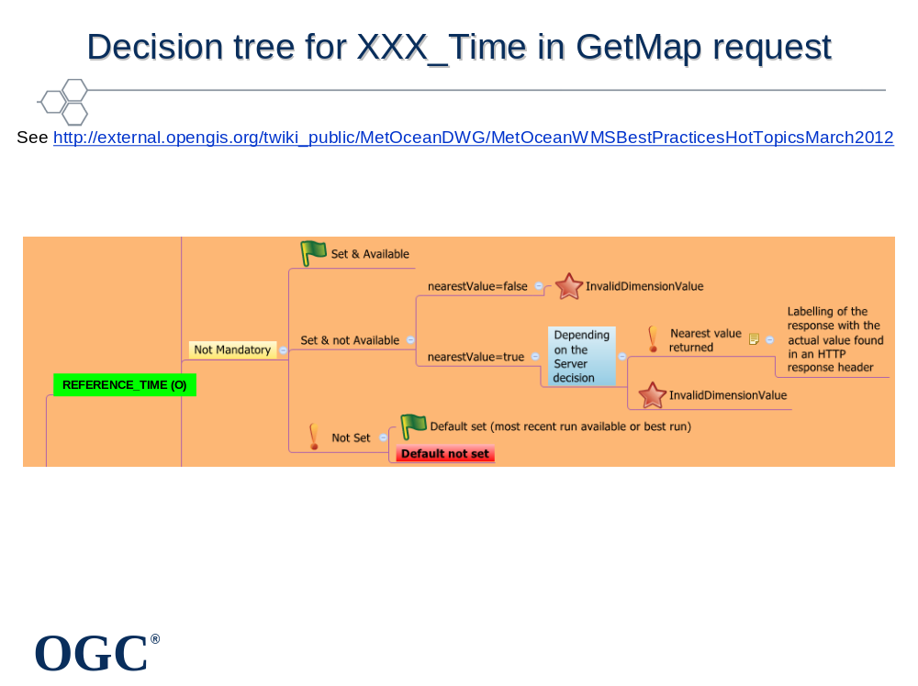
Climatological Time
The examples are not necessarily exhaustive but reflect some of the climatology time issues

Two broad areas for time
  - Time related calculations
    - How the reanalysis data will be summarized for the user selected time periods
    - It is not completely clear whether this is OGC WMS time axis related but may at least inform some time axis defaults
  - Time periods
    - Which time periods may be selected from the reanalysis dataset
    - This is probably OGC WMS time axis related

Time Related Calculations
- Mean
  - Average is calculated from the dates selected by the user
- Long Term Mean
  - Average is calculated over the entire time range of the underlying dataset
- Anomaly
  - Mean values minus the long term mean values
- Probability Threshold
  - Computes the probability of a value being exceeded or not reached based on the long term mean values
A controlled vocabulary has to be defined for classical statistical calculations

Use case : Single Day Time Selection
- Single date is selected by user
  - E.g., December 1
- The calculation will composite the underlying data from the single date to include
  - Hours of the day selected by the user E.g., based on the data in the underlying data set such as 0Z, 3Z, 6Z, …
  - Years selected by the user E.g., 2007, 2008, 2009, …

- Best practice : If the client wants to make a request on one single day over several years, it can be expressed easily as a sequence of days.

- Example values for TIME argument in the GetMap request :
Example every Dec. 1, 2007-2011 : TIME=2007-12-01/2011-12-01/P1Y
Example every Dec. 1 at 03Z, 2007-2011 : TIME=2007-12-01T03/2011-12-01T03/P1Y
If the client wants to make a request on one single day over several years, it can be expressed easily as a sequence of days.

Example values for TIME argument in the GetMap request. Single day, multiple years:
Example every Dec. 1, from 2007-2011 :
TIME=2007-12-01/2011-12-01/P1Y
Example every Dec. 1 at 03Z, from 2007-2011 :
TIME=2007-12-01T03/2011-12-01T03/P1Y
Use case : Span of Days Time Selection
- Begin and end date selected by user
  - E.g., December 1-31

- The calculation will composite the underlying data from the time range to include
  - Hours of the day selected by the user : E.g., based on the data in the underlying data set such as 0Z, 3Z, 6Z, …
  - Years selected by the user : E.g., 2007, 2008, 2009, …

- Best Practice : Example values for TIME argument in the GetMap request. Arbitrary range of days, multiple years:
- Example : User requests Nov 15-Dec 15, from 2007-2011 :
- TIME=2007-11-15/2007-12-15,2008-11-15/2008-12-15,2009-11-15/2009-12-15,2010-11-15/2010-12-15,2011-11-15/2011-12-15

Example values for TIME argument in the GetMap request. Arbitrary range of days, multiple years:
User requests Nov 15-Dec 15, from 2007-2011 :
TIME=2007-11-15/2007-12-15,2008-11-15/2008-12-15,2009-11-15/2009-12-15,2010-11-15/2010-12-15,2011-11-15/2011-12-15
Composite of Months Time Selection
- Months are selected by user
  - E.g., January, February, March

- The calculation will composite the underlying data for the selected months to include
  - Hours of the day selected by the user
    - E.g., based on the data in the underlying data set such as 0Z, 3Z, 6Z, …
  - Years selected by the user
    - E.g., 2007, 2008, 2009, …
    - Default if user does not select one or more years is to composite all available years into the calculation

Enumerations could be a solution there.

Range of months, multiple years:
TIME=2007-01/2007-03,2008-01/2008-03,2009-01/2009-03,2010-01/2010-03,2011-01/2011-03

Conditional Selection Time Selection
- User selects lowest and highest Mutivariate El Nino/Southern Oscillation (ENSO) Index (MEI) values

- The calculation will composites months with values that fall within those limits
  - User can limit selection to months of interest with values within identified MEI values
This use case is not anymore a time period but the result of a filter. It is out of the scope of this best practices?
Maybe it is a filter if adressing a selection of data with a WCS but considering a WMS it can be a product

Use case is real so it is the sope of the Met Ocean domain working group but out of the scope of this BP
Handling Climatologies (STILL UNDER DISCUSSION)
- Proposal to put as few semantics as possible into the layer name

- May need combination of descriptive Layer names :
e.g., "Mean of January temperatures from 2000-2009“ : =>Layer="mean_temperature" & TIME=2000-01/2009-01/P12M

- Periods should be referenced from their beginning (not middle or end of the period)
- Use case : Anomaly of a mean parameter calculated over a certain period compared to the same mean parameter calculated over a reference period Example: Anomaly of Mean Temperature over January 2011 compared to Mean temperature of January Monthes from 1980 to 2000
- The period of reference cannot be a dimension as it is not continuous. It is a reference period that should be set as a metadata
- An attribute has to be a dimension if clients can base a request on it , if not it is a metadata
The first proposal to put as much semantics as possible into the layer name has been rejected.
The new proposal is to put as *few* semantics as possible into the layer titles. Any qualifiers related to location or time should be kept out of the layer titles.
Layer name can be an arbitrary identifier (e.g. a UUID) - something that a user of a WMS will never get in touch with. It is merely used as a primary key to identify the layer within a service and should be handled that way.

Typically encoding time or location in the layer title is bad if used for routine attributes that could be dimensions. E.g., use TIME and ELEVATION instead of temperature_at_1000mbar or temperature_2012-06-04. There might be exceptions for special collections or subsets focusing on events or locations of note, such as before/after imagery for a particular tsunami.
Considering that a mean temperature is different from a temperature then a descriptive layer title should be used.
But this can lead to a lot of layers as a lot of statistical and arithmetic operations can be applied in climatology and Ensemble Prediction outputs (Mean, Min, Max…)

Several proposal have been made to manage the calculation procedures :
As layers Keywords :
What we could do instead is to put the calculation procedure and the phenomenon in the WMS layer's keywords:
<Layer>
...
<KeywordList>
<Keyword vocabulary="http://wmo.int/somedictionary">
mean_temperature
</Keyword>
<Keyword ...>
...
</Keyword>
</KeywordList>
...
<Layer>
Describe it into the Metadata
If for a given layer (e.g., temperature) you have only one procedure, then describe it in the Layer metadata.

As a new dimension if there are many of them
However, if there are multiple procedures to choose from (e.g., I have Sea Surface Temperature from satellite instruments (GOES, TMI, MODIS, AVHRR, AMSRE), and an integrated dataset (GHRSST), then I think a new sample dimension (e.g., PROCEDURE) should be used to (a) advertise the options and (b) allow the user to select among them.
...GetMap&Layers=sea_surface_temperature&procedure=ghrsst&time=2012-06-04&...

Other time concepts useful for meteorological, climatological and oceanographic uses
- REFERENCE_TIME_PERIOD ou AGGREGATION_TIME_PERIOD : Accumulation period needed to publish into the getcapabilities the accumulation periods available for instance for rain accumulations

- Remark: accumation-periods can be a dimension or define new parameters but is not a time axis
END FOR TIME ISSUES
Multiple model runs that are started with the same reference_time
- Multiple model runs that are started with the same analysis_time
  - Need a "process ID" or "run ID" axis

Vertical Axes in WMS: General
- General rules for all cases:
  - Each Layer may have 1 ELEVATION axis <Dimension name="elevation">
  - ELEVATION axis must have a well-defined vertical CRS (coord. ref. syst.)
    - Mandatory attribute : verticalCRSid (label or URL) - see Clause 6.7.5
  - Elevations shall be expressed in units of this CRS
    - Required attribute : unitSymbol corresponds to these units
  - ELEVATION axis (if present) shall enumerate 1+ available values
  - Multiple elevations may be expressed either as a list or as a min/max/interval, as shown in WMS 1.3 Table C.2.
  - Express each map as a single Layer with 0 or 1 elevation axes
  - Avoid multiple independent layers with elevation encoded in Name.
Vertical Axes in WMS: Simple Cases
- Case 1: Layer with no defined Elevation
  - Omit ELEVATION
  - Avoid inheritance of ELEVATION from parent layers
  - Client: ELEVATION in GetMap request is ignored for this layer

- Case 2: Layer with single known Elevation
  - ELEVATION axis states 1 elevation value (Z)
  - Mandatory attributes: nearestValue=TRUE, default=Z
  - Client: ELEVATION in GetMap request is ignored for this layer
Vertical Axes in WMS: Continuous Axis
- Case 3: Layer with multiple available elevations
  - Continuous, monotonic axis with defined vertical CRS, e.g.:
    - CRS:88 = North American Vertical Datum 1988. unitSymbol=m (see B.5)
    - ? = Geopotential Height. ID & ISO 19111 definition t.b.d. unitSymbol=m.
    - ? = Pressure Level. ID & definition t.b.d. unitSymbol=hPa (or mbar?).
    - ? = Flight Level. ID & definition t.b.d. unitSymbol=FL.
  - ELEVATION axis states available vertical values {Zi}
    - List (Z0, Z1,... ZN) and/or range (Z0,/Z1/ΔZ) [see WMS Table C.2]
  - Recommended attributes:
    - default= Zdefault (what elevation will be sent if client does not specify)
    - nearestValue=TRUE (nearest available elevation will be sent)
    - multipleValues=FALSE (each map usually represents single elevation)
  - Client: ELEVATION=Z in GetMap request is used to choose vertical value
Vertical Axes in WMS: Computed Surfaces
- Case 4: Values predicted on computed surfaces
  - Canonical Use Case: Aviation weather products
    - Example: Wind speeds computed for tropopause, mean sea level (MSL), isotherms (Iso T), base and top of contrail layer (COTRA), surfaces of constant potential vorticity (PVU), Jet level
    - See http://external.opengis.org/twiki_public/MetOceanDWG/MetOceanWMSBP20120206
  - Use <DIMENSION name="computed_surface"> to enumerate
    - Element contains comma-separated list of available surfaces, e.g.:
      - <Dimension name="computed_surface">Tropopause, MSL, 0.7PVU, Jet_level, ISO_T0, 2nd_Iso_T0</Dimension>
    - Attributes: nearestValue=FALSE, multipleValues=FALSE, default=name
  - Client: DIM_COMPUTED_SURFACE=name in GetMap request is used to choose desired surface
Issues to be Resolved on vertical CRSs
- Community-specific vocabulary(ies) for surface names
- How to handle same quantity available both on computed surfaces and at normal elevation levels
  - Possibly ambiguous or conflict GetMap requests
- ISO 19111 definitions of common vertical CRSs (pressure, GPH, etc)
Case 3 : WMS Layer with multiple Time axis
- Server:
  - <Dimension name="TIME"> : validity times
  - For each further time axis
    - <Dimension name=“<time-name>_TIME"> where <time-name> is the name of a time axis
    - List (T0, T1,... TN) and/or range (T0/T1/ΔT) [see WMS Table C.2]
  - Recommended attributes for each time dimension:
    - current=TRUE (if data are continually updated)
    - default=Tdefault (what time will be sent if client does not specify)
    - nearestValue=TRUE (nearest available time will be sent)
- Client:
  - TIME and all DIM_<time-name>_TIME are recommended in GetMap request
  - Decision tree on next slide
Discussions Teleconf 2012-05-07:
As the production in the Met Ocean Community is evolutive, we wish to define flexible standards able to cover all use cases.
But this is not compatible with interoperability which is the aim of this Best Practices work.
So we will cover this very general case but express that :
- it should be used only if really necessary ,
- before or at the moment of implementing this, the implementors should express a change request to update the Best practices doc to harmonise a name for the use case that requires a new time concept that leads to this new time dimension.
Decision tree for <time_name>_Time in GetMap request
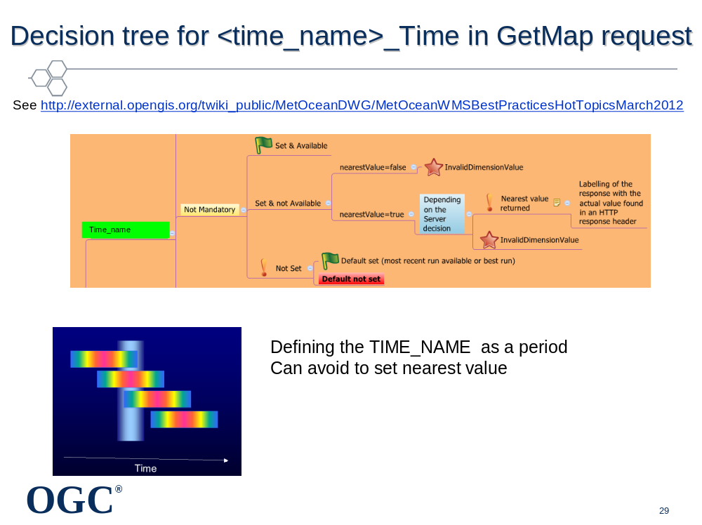

Annex of notes, reminders, etc. To be deleted when complete.
Get reviews from Adrian Custer, Joan Maso, WMS telcos, Jeremy Tandy and co.
DECISION: Intercept WMS 1.3. Make new one for WMS2.0.
Triage features into: stay same, need to change, don’t know
Pick up details and examples from MoD Profile
Legend: problematic
DECISION: MUST support PNG for transparency as a minimum. SVG nice. Same as WMS 1.3
DIMENSIONS
Names and title
Keyword list
Styles?
Queryable layers LATER?
Bounding box
CRS
Scale
Data URL ?
Null/negative responses.
Table 1 UNCHANGED
Table 2 UNCHANGED
Table 3 — The parameters of a GetCapabilities request URL
Request parameter | Mandatory / optional | Description | Met Ocean Profile
VERSION=version | O | Request version | M
SERVICE=WMS | M | Service type | No change
REQUEST=GetCapabilities | M | Request name | No change
FORMAT=MIME_type | O | Output format of service metadata | ?
UPDATESEQUENCE=string | O | Sequence number or string for cache control | ?

Table 4 — Use of UpdateSequence parameter UNCHANGED
Client request UpdateSequence value | Server metadata UpdateSequence value | Server response | Met Ocean profile
None | any | most recent service metadata | No change
Any | none | most recent service metadata | No change
equal | equal | Exception: code=CurrentUpdateSequence | No change
Lower | higher | most recent service metadata | No change
higher | lower | Exception: code=InvalidUpdateSequence | No change

Table 5 — Relationship between ISO 19128 and ISO 19115 metadata fields
ISO 19128 layer property | ISO 19115 Metadata element | Relationship
Title | CI_Citation.title | equivalent | Check WMO core Profile
Abstract | MD_DataIdentification.abstract | equivalent | Check WMO core Profile
Keyword element inKeywordList | MD_TopicCategoryCode | equivalent if “vocabulary” attribute of 19128 <Keyword> element is “ISO 19115:2003”. Other vocabularies are permitted by 19128. | Check WMO core Profile
EX_GeographicBoundingBox | EX_GeographicBoundingBox | equivalent | No change
CRS | MD_CRS | Value of CRS in 19128 is a text string that identifies a coordinate reference system defined by another authority. Value of MD_CRS in 19115 is a list of projection, ellipsoid and datum identifiers. | ??
BoundingBox | EX_BoundingPolygon | 19128:BoundingBox is strictly a box (lower left and upper right corners in a specified CRS). 19115:EX_BoundingPolygon may be a polygonal boundary. | ??
Attribution | CI_ResponsibleParty | Title element of 19128:Attribution is equivalent to organisationName element of 19115: CI_ResponsibleParty. Other elements of 19128:Attribution have no equivalent in 19115. | Check WMO core Profile
Identifier and AuthorityURL | CI_Citation.identifier | The value of 19128:Identifier is equivalent to 19115:CI_Citation.identifier.code. 19128:AuthorityURL contains only the URL of the authority for a namespace, and is equivalent to 19115: CI_Citation.identifier.citation.citedResponsibleParty. contactInfo.onlineResource. 19115 allows a fuller description of the namespace authority. | Check WMO core Profile
DataURL | MD_metadata.dataSetURI | equivalent | No change

Table 6 — Layer attributes
Attribute | Allowed values | Meaning (0 is default value) | Met Ocean Profile
queryable | 0, false, 1, true | 0, false: layer is not queryable. 1, true: layer is queryable. | ??
cascaded | 0, positive integer | 0: layer has not been retransmitted by a Cascading Map Server. n: layer has been retransmitted n times. | No change
Opaque | 0, false, 1, true | 0, false: map data represents vector features that probably do not completely fill space. 1, true: map data are mostly or completely opaque. | No change
noSubsets | 0, false, 1, true | 0, false: WMS can map a subset of the full bounding box. 1, true: WMS can only map the entire bounding box. | No change
fixedWidth | 0, positive integer | 0: WMS can produce map of arbitrary width. nonzero: value is fixed map width that cannot be changed by the WMS. | No change
fixedHeight | 0, positive integer | 0: WMS can produce map of arbitrary height. nonzero: value is fixed map height that cannot be changed by the WMS. | No change

Table 7 — Inheritance of Layer properties
Element | Number | Inheritance | Met Ocean Profile
Layer | 0+ | no | No change
Name | 0/1 a | no | No change
Title | 1 | no | No change
Abstract | 0/1 | no | No change
KeywordList | 0/1 | no | No change
Style | 0+ | add | No change
CRS | 1+ b | add | No change
EX_GeographicBoundingBox | 1 b | replace | No change
BoundingBox | 1+ b | replace | No change
Dimension | 0+ | replace | No change
Attribution | 0/1 | replace | No change
AuthorityURL | 0+ | add | No change
Identifier | 0+ | no | No change
MetadataURL | 0+ | no | No change
DataURL | 0/1 | no | No change
FeatureListURL | 0/1 | no | No change
MinScaleDenominator,  MaxScaleDenominator | 0/1 | replace | No change
Attributes listed in Table 6 | 0/1 | replace | No change
a See 7.2.4.6.3 regarding distinction between named and unnamed layers.
b May be 0 only if a value is inherited from an enclosing Layer element; see 7.2.4.6.6 through 7.2.4.6.8
Table 8 — The Parameters of a GetMap request
Request parameter | Mandatory / optional | Description | Met Ocean Profile
VERSION=1.3.0 | M | Request version. | No change
REQUEST=GetMap | M | Request name. | No change
LAYERS=layer_list | M | Comma-separated list of one or more map layers. | No change
STYLES=style_list | M | Comma-separated list of one rendering style per requested layer. | No change
CRS=namespace:identifier | M | Coordinate reference system. | No change
BBOX=minx,miny,maxx,maxy | M | Bounding box corners (lower left, upper right) in CRS units. | No change
WIDTH=output_width | M | Width in pixels of map picture. | No change
HEIGHT=output_height | M | Height in pixels of map picture. | No change
FORMAT=output_format | M | Output format of map. | No change
TRANSPARENT=TRUE|FALSE | O | Background transparency of map (default=FALSE). | ??
BGCOLOR=color_value | O | Hexadecimal red-green-blue colour value for the background color (default=0xFFFFFF). | ??
EXCEPTIONS=exception_format | O | The format in which exceptions are to be reported by the WMS (default=XML). | No change
TIME=time | O | Time value of layer desired. | ??
ELEVATION=elevation | O | Elevation of layer desired. | ??
Other sample dimension(s) | O | Value of other dimensions as appropriate. | ?? Add more detail e.g.  2nd time  probability threshold

Table 9 — The Parameters of a GetFeatureInfo Request
Request parameter | Mandatory / optional | Description | Met Ocean Profile
VERSION=1.3.0 | M | Request version. | No change
REQUEST=GetFeatureInfo | M | Request name. | No change
map request part | M | Partial copy of the Map request parameters that generated the map for which information is desired. | No change
QUERY_LAYERS=layer_list | M | Comma-separated list of one or more layers to be queried. | No change
INFO_FORMAT=output_format | M | Return format of feature information (MIME type). | ?? XML+Schema?
FEATURE_COUNT=number | O | Number of features about which to return information (default=1). | No change
I=pixel_column | M | i coordinate in pixels of feature in Map CS. | No change
J=pixel_row | M | j coordinate in pixels of feature in Map CS. | No change
EXCEPTIONS=exception_format | O | The format in which exceptions are to be reported by the WMS (default= XML). | ??

B.2 Map CS (CRS:1)
Table B.1 — Definition of map coordinate system
Element name | Entry | Comment | Met Ocean Profile
Coordinate system identifier | CRS:1 | See 6.7.2
Coordinate system type | Cartesian
Datum identifier | computer display
Datum type | engineering
Coordinate system dimension | 2
Coordinate system axis name | i
Coordinate system axis direction | east | Some maps, especially over the poles, may not have a well-defined linear axis direction.
Coordinate system axis unit identifier | pixel
Coordinate system axis name | j
Coordinate system axis direction | south | Some maps, especially over the poles, may not have a well-defined linear axis direction.
Coordinate system axis unit identifier | pixel
Coordinate system remarks | Origin is in upper left. Axis values are non-negative integers.

B.3 Layer CRS using WGS 84 longitude-latitude (CRS:84)
Table B.2 — Definition of Layer CRS using WGS 84 longitude-latitude
Element name | Entry | Comment | Met Ocean Profile
Coordinate reference system kind code | 1 | Single (not compound) CRS
Coordinate reference system identifier | CRS:84
Coordinate reference system valid area | world
Datum identifier | WGS 84
Datum type | geodetic
Prime meridian identifier | Greenwich
Prime meridian Greenwich longitude | 0 degree
Ellipsoid identifier | WGS 84
Ellipsoid semi-major axis | 6378137.0 m |  | ?? Cross check
Ellipsoid shape | true
Ellipsoid inverse flattening | 298.257223563 |  | ??Cross check
Coordinate system identifier | Geodetic Coordinate System
Coordinate system type | geodetic
Coordinate system dimension | 2
Coordinate system axis name | longitude | The first (x) axis is longitude in this CRS.
Coordinate system axis direction | east
Coordinate system axis unit identifier | degree
Coordinate axis minimum value | −180 degrees
Coordinate axis maximum value | 180 degrees
Coordinate system axis name | latitude | The second (y) axis is latitude in this CRS.
Coordinate system axis direction | north
Coordinate system axis unit identifier | degree
Coordinate axis minimum value | −90 degrees
Coordinate axis maximum value | 90 degrees
NOTE CRS:84 is permitted to be used at large scales (>10m/pixel) for describing or requesting map layers in any lon/lat
CRS that is equivalent to within ~1m.

Add something like B.6
Table C.1 — Contents of a dimension element
Field | Mandatory / optional | Meaning | Met Ocean Profile
name | M | Attribute stating name of dimensional axis. | No change
Units | M | Attribute indicating units of dimensional axis. | No change
unitSymbol | O | Attribute specifying symbol.
Default | O | Attribute indicating default value that will be used if GetMap request does not specify a value. If attribute is absent, then shall respond with a service exception if request does not include a value for that dimension. | M?
multipleValues | O | Boolean attribute indicating whether multiple values of the dimension may be requested. 0 (or “false”) = single values only; 1 (or “true”) = multiple values permitted. Default = 0.
nearestValue | O | Boolean attribute indicating whether nearest value of the dimension will be returned in response to a request for a nearby value. 0 (or “false”) = request value(s) must correspond exactly to declared extent value(s); 1 (or “true”) = request values may be approximate. Default = 0.
current | O | Boolean attribute valid only for temporal extents (i.e. if attribute name="time"). This attribute, if it either 1 or “true”, indicates (a) that temporal data are normally kept current and (b) that the request parameter TIME may include the keyword “current” instead of an ending value (see C.4.1). Default = 0. | M?
Extent | M | Text content indicating available value(s) for dimension. | No change

www.opengeospatial.org/cite

