Introduction to Use Case description
(It is schematic outline and very draft material for free utilization)

- Conceptual model (meta-model) of groundwater flow models

- Essential elements of groundwater flow model:
  - Simulator (software system) based on groundwater flow equation, for example for unsteady state 2D (or 2.5D in one layer flow):
  - Data sets about modeled groundwater flow system. Data sets should fulfill requirements simulator and equation. Requirements concern content of data and form encoding.

- 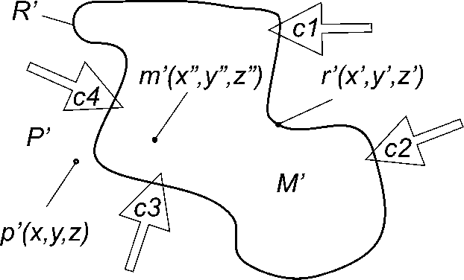

Figure 1. Schematic relations between main components of fundamental conceptual model.
Explanation:
R' – boundary of system – set of boundary points r'(x',y',z') ∈ R',
M' – interior of system – set of interior points m'(x",y",z")) ∈ M',
P' – exterior (surroundings) – set of points p'(x,y,z) ) ∈ P' belong to surroundings,
c1, c2, c3, c4 – impacts of surroundings on interior of system.

- Main components of model as a boundary value problem (figure 1):
  - Interior – physical space of groundwater flow in modeled system. It can be modeled as 1D (linear), 2D, 2.5D (layered) or 3D space. It is modeled hydrogeological system as a composition of static aquifer system and dynamic groundwater flow system. Aquifer system is a collection of aquifers and aquitards. It can be surrounded by aquicludes. Groundwater flow system as a dynamic has state changeable in time for unsteady flow or unchangeable for steady flow. State is determined by impacts of surroundings which are expressed in the model by boundary conditions.
  - Boundary (of interior) – Spatial dimension is one step lower. For example represented by two points (0D) for linear (1D) interior. Boundary conditions should be specified for every part of boundary.
  - Exterior (surroundings) – space in the same dimension as an interior. “Exterior” can be placed inside of interior and in these case is separated from interior by internal boundary
  - Boundary conditions – expressing impact of exterior on interior. Different types of boundary conditions are specified for different types of impacts. Generally there are three types of boundary conditions:
    - Dirichlet’s condition for determining piezometric head (water table height),
    - Neumann’s condition for determining quantity of flow,
    - Robin’s (or Cauchy’s) condition for determining linear combination of Dirichlet’s and Neumann’s condition
  - Function of internal state – expressing result of impact.
  - Physical (hydraulic) parameters of interior – determining response of interior to inpact.
  - Physical (hydraulic) parameters of boundary – describing kind and range of impact.
  - Initial conditions – only for unsteady state flow – determining initial state of interior.

Spatial relations between listed above elements of the flow model is expressed by spatial (geometric) model of hydrogeological system. It describe part of underground space by location, extend, boundaries and division into spatial components, for example aquifers and aquitards.

For all specified above components of the model it should be specified appropriate input data sets. The content of these data sets depends on type of model, selected flow equation and spatial dimension of the model. In consequence it depends on selected simulator as a software system. There are many different kinds of simulators, for example MODFLOW or ASPAR and each of them need different form of data encoding but content of data sets is very similar.
In consequence, method of encoding (data format or language) should be independent of type of simulator. It should be a “common denominator” transformable to requirements of specific kind of simulator.

- Groundwater data processing chain for groundwater flow models needs

Most often groundwater flow modeling is a final stage of hydrogeological research. Is takes possibility to verify correctness of all previous stages and achieved results. It is done by mathematical simultaneous comparison all input data sets and result can point which data part is incorrect or not enough accurate. Schematic description of groundwater data processing chain for groundwater flow models needs is presented in table 1.

Table1. Hydrogeological data processing chain
 | Stage | Input | Result | Example | Type of data | Service (if applicable)
1. | Observation and measures | Measure in point | Row point data | Deep of groundwater table | Point features | SOS,  WFST
2. | Data calibration | Row point data | Calibrated point data | Piezometric head (groundwater table height) relative to see level | Point features | WTS,  XSLT (Extensible Stylesheet  Language Transformations)
3. | Data aggregation | Calibrated points data | Data as a points collections | Collection of piezometric values | Discrete point coverage | WTS or WPS
4. | Data transformation | Data as a point collections | Data transformed to grid | Hydrogeological surface (piezometric surface, roof or floor of aquifer or aquitard) | Rectified grid coverage | WPS
5. | Data processing by groundwater flow models | Data transformed to grid | Data sets as an output from models | Verified piezometric surface, streamlines, velocity vectors or other physical fields concerning groundwater | Rectified grid coverage | WPS
6. | Data analysis | Data sets as an output from models | Data sets as a final results of complex research works | 3D (or 2.5D or 2D) model of hydrogeological system | Complex data set of sets as:  rectified grid coverages and several other data types | -

- Reuse of groundwater flow models data

All available data concerning modeled hydrogeological system should be used. Not only collected while works in the field but also obtained from other groundwater flow models, especially if those models cover modeled area or border on it. Coincident grids of models (fig. 2.) make reuse considerably easier and more precise.

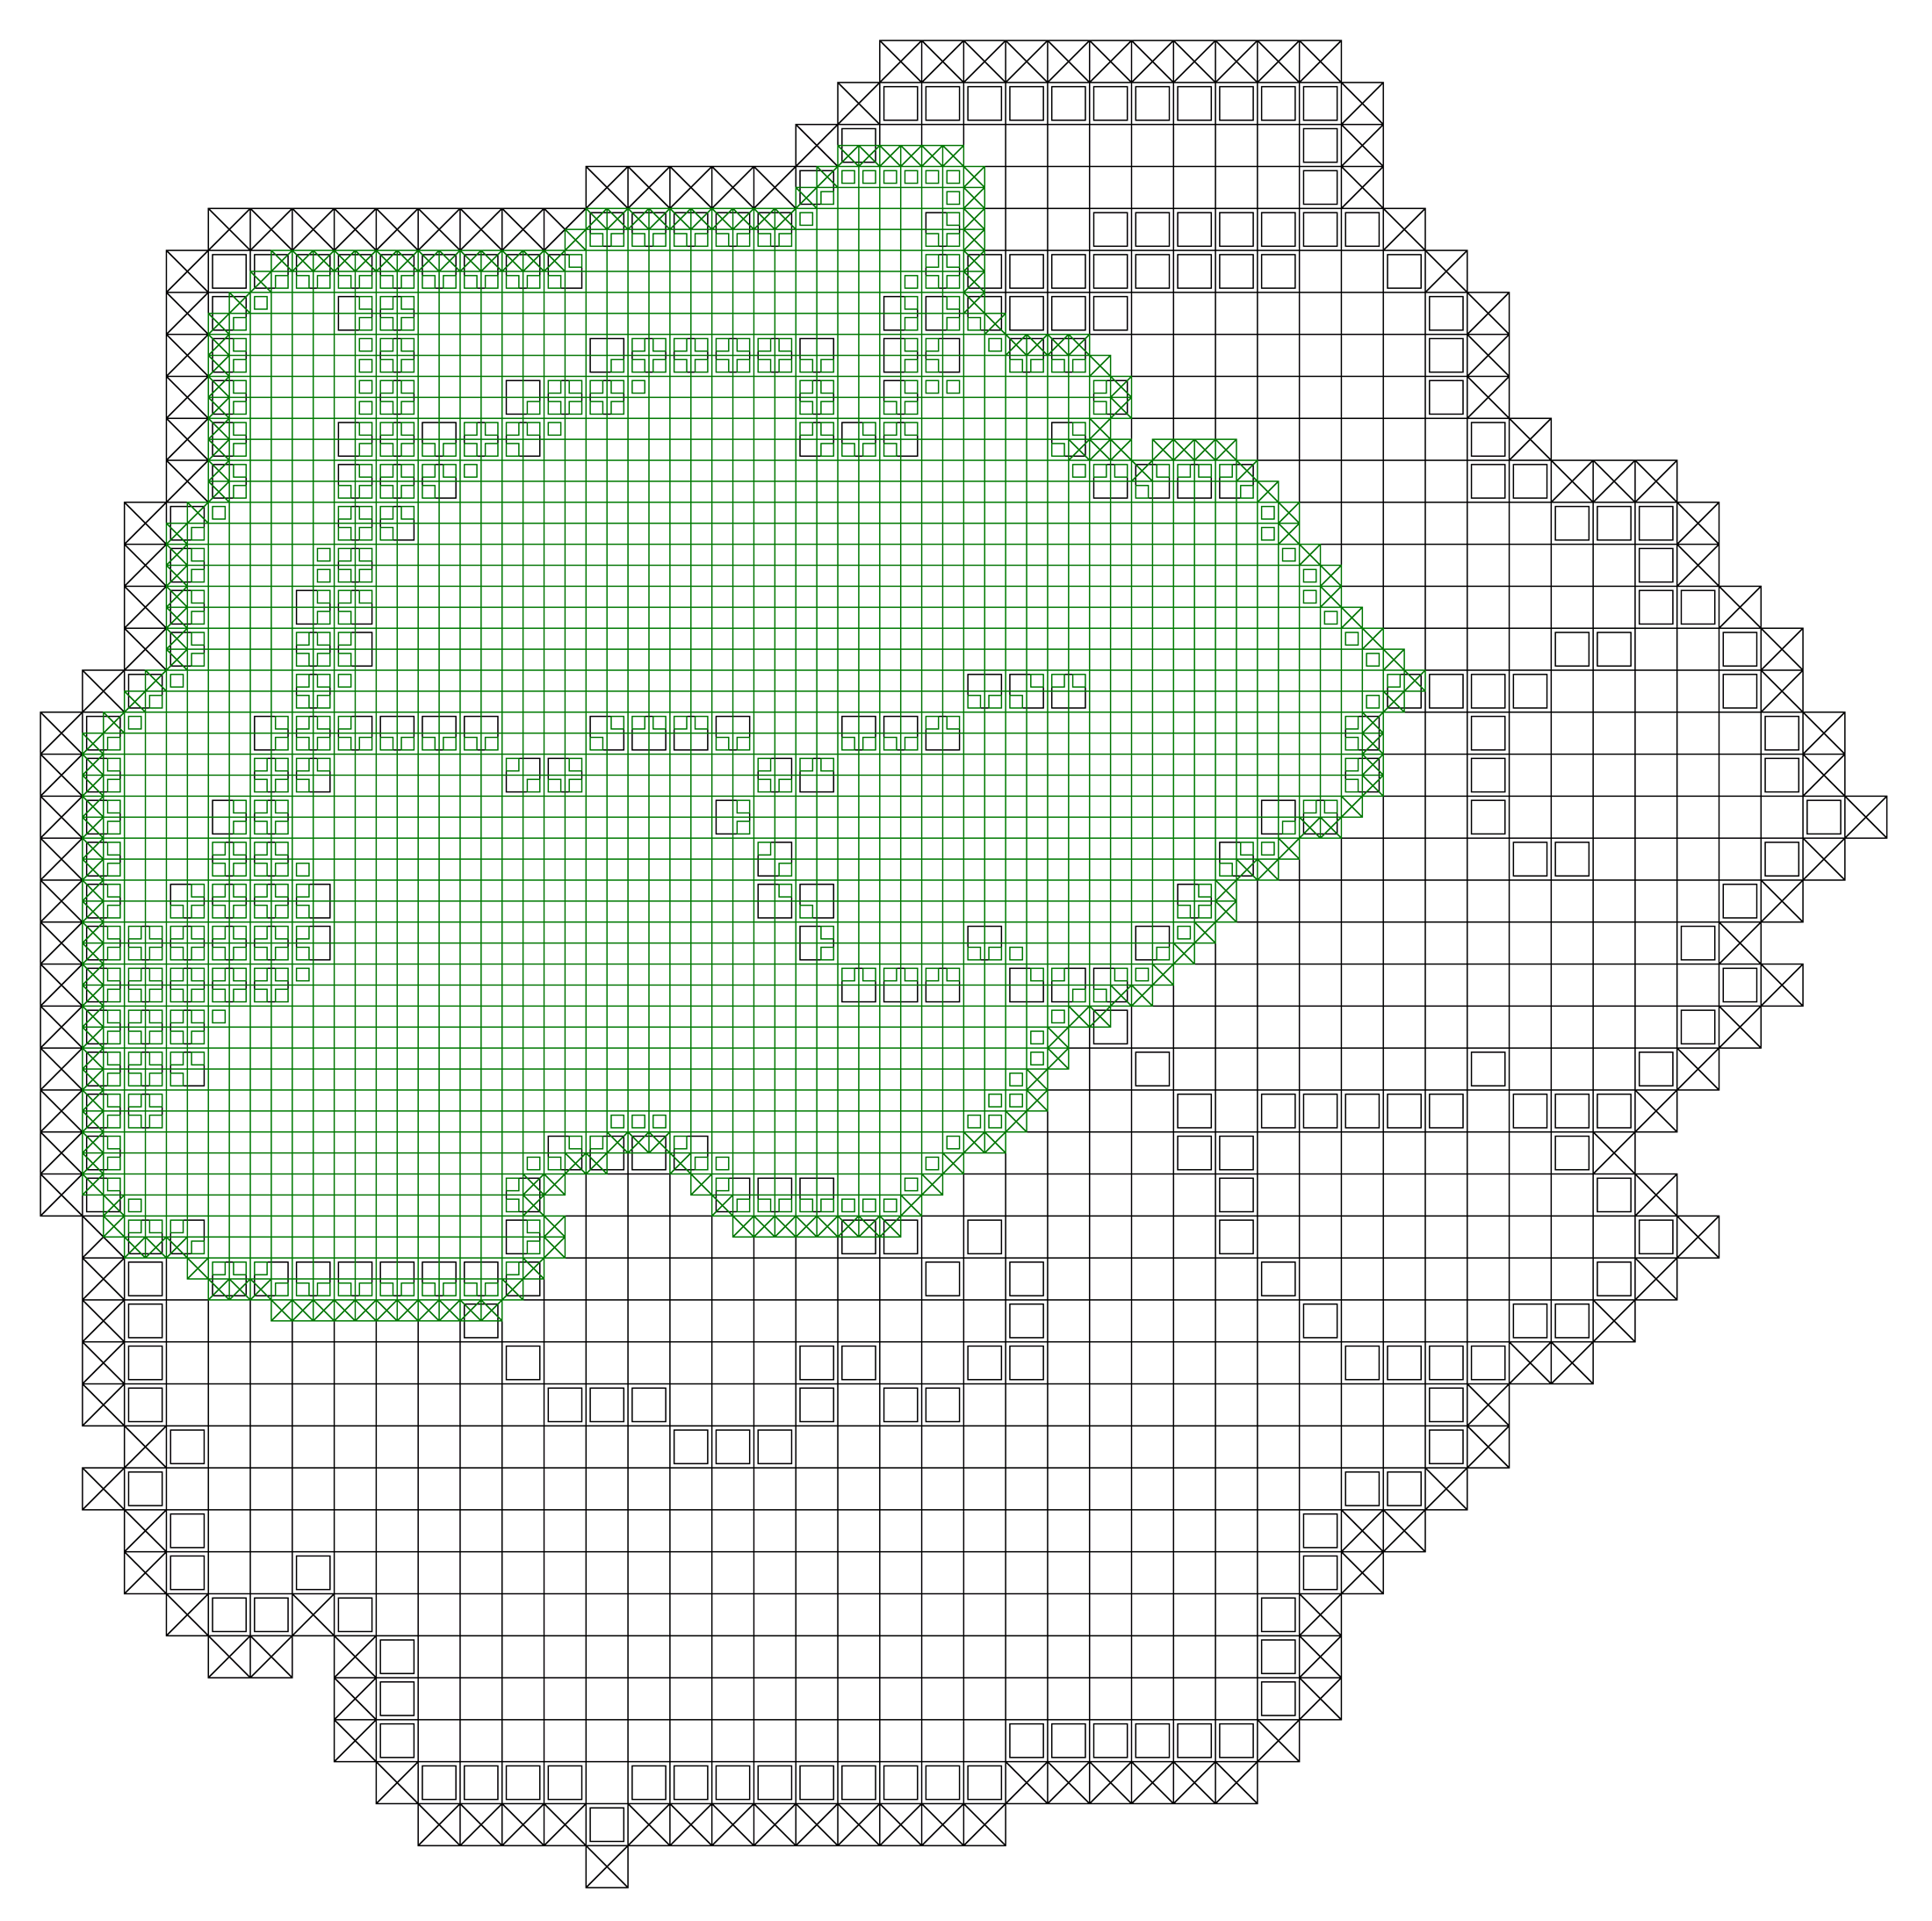

Figure 2. Two coincident grids of two different models. Black lines – older less detailed model of larger area, green lines – new more detailed model of part that area.

- List of types of data sets needed for groundwater flow modeling

- Spatial model of hydrogeological system:
  - Geologic Units: boundaries and lithology.
  - DEM.
  - Geologic boreholes: location and lithological profiles.
  - Wells: locations and lithological profiles.
  - Results of geophysical investigations.
  - Hydrographic bodies as boundaries of hydrogeological system.
- Hydrogeological parameters of aquifer system:
  - Results of field and laboratory works – permeability coefficient, storage coefficient and others.
  - Results of wells pumping tests
  - Lithology of aquifers and aquitards
  - Other data determining hydrogeological parameters.
- Boundary conditions:
  - Surface water level height – streams, rivers and lakes as a base of drainage.
  - Active wells: location and quantity of drawing or injection.
  - Parameters and physical values determining of feeding (recharge).
  - Data about other man-made object having impact on state of groundwater flow system.
- State of groundwater flow system:
  - Piezometric head (groundwater table height) in observation wells and other man-made non-active object.
  - Data about directions and rates of flow.
  - Data about chemical (quality) state of groundwater bodies.
- Other auxiliary data:
  - Land caver.
  - Land usage.
  - Topographic and orthophoto data as a spatial reference.
  - Climatic data
  - Data about protected areas
  - Data about sources of contamination

