GWML2.0 – well test proposal

# Input

From twiki:

* to be added: well test class (procedure/process for conducting a pumping test
* Proposal to be drafted for next meeting: ideas/examples to be sent to Sylvain (lead)
* Contains: inputs, results, methods, time
* Potentially model as subclass of OM_Observation or OM_Process; results as GW_FluidProperties.
* Add as attribute to Well (to directly link a well test to a well... as a convenient short-cut)

# Context

In the French Water Information and in BRGM data bases the information is structured as follows (don’t worry English translation below the snapshot).

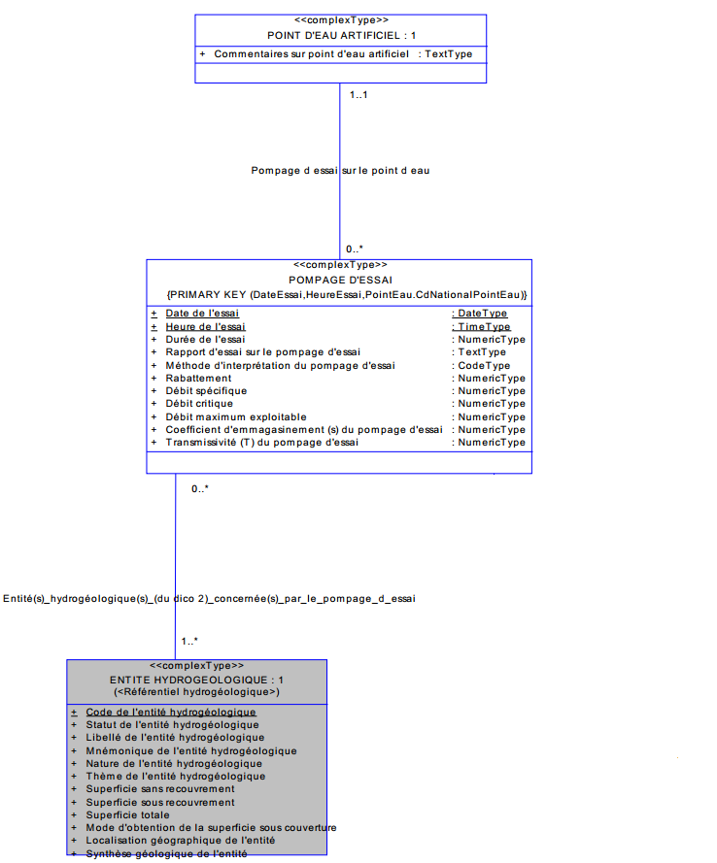

Well test (‘POMPAGE D’ESSAI’) is associated with

* 1..1 GW_Well (‘POINT D’EAU ARTIFICIEL’ )
* 1..* GW_HydrogeoUnit (‘ENTITE HYDROGEOLOGIQUE’)

Well test has the following attributes.

|  |  |  |
| --- | --- | --- |
| **Attribute Name French** | **English translation** | **Mapping to O&M** |
| Date de l'essai | Well test date | phenomenonTime |
| Heure de l'essai | Well test time |
| Coefficient d'emmagasinement (s) du pompage d'essai | Well test storage capacity measured | observedProperty |
| Débit critique | critical yield | observedProperty |
| Débit maximum exploitable | maximum yield | observedProperty |
| Débit spécifique | specific yield | observedProperty |
| Durée de l'essai | well test duration | resultTime (or deducted from) |
| Méthode d'interprétation du pompage d'essai[1] | welltest interpretation method | Procedure |
| Rabattement | Drawdown | observedProperty |
| Rapport d'essai sur le pompage d'essai | well test report | URL to the report in KVP via parameter ? |
| Transmissivité (T) du pompage d'essai | well test measured transmivity | observedProperty |

Most of those attributes easily fit into O&M.

* Well test is definitely an Observation.

But we have already modelled couple of UnitFluidProperties (GW_UnitFluidProperty)

* **The question is: how does well test fit into GWML2.0 ?**

# Solution 1 : No shortcut

Everything is already here. ‘Well test’ is a use case already supported by our model

The instance diagram below reuses the links from GW_Well -> GW_HydrogeoUnit -> GW_UnitFluidProperty

For simplicity sake, we just try to exchange critical Yield.



Pros

* No need to complexify the model

Cons

* No way to properly identify in the instances that we are handling ‘well test’ result. Apart from best practices in pointing to the ‘OM_Process) (naming the ‘wellTestInterpretationMethod’, …)
* Each well test parameter will store the same values for the parameters: ‘Well test date’, ‘Well test time’, ‘Well test duration’, …
* Both Cons could be solved by
  + Adding an overarching OM_Observation with OM_Process ‘well test’. Overarching OM_Observation having relatedObservation (gwHydraulicConductivity, gwStorativity, gwTransmissivity, gwYield).

=> most of which will share the same OM_Process, ‘phenomenonTime’, ‘resultTime’, …

=> what would be the observedProperty of such overarching OM_Observation ?

* + or with a single OM_ComplexObservation
* But solutions lead to add something to the model.
* Might need to revisit the way we modelled ‘GW_UnitFluidProperty ‘ as, yes, the well test is a specific context but observedProperty (ies) are the same as in GW_UniFluidProperty

# Solution 2: Shortcut version

Choice : adding a wellTest association to an OM_Observation.

Not reusing the links from GW_Well -> GW_HydrogeoUnit -> GW_UnitFluidProperty

For simplicity sake, we just try to exchange critical Yield.



Pros

* Well Test is now explicitly visible in the data model

Cons

* How do we restrict to a given GW_HydroGeoUnit ? as there is no direct link from the OM_Observation to the GW_HydroGeoUnit (via the parameter attribute ? -> don’t like that)
* Risk of inconsistencies with information stored using the link from GW_Well -> GW_HydrogeoUnit -> GW_UnitFluidProperty
* Again we might have duplication of OM_Process, 'phenomenonTime', 'resultTime', … which lead to either create :
  + an overarching OM_Observation with related observations : gwHydraulicConductivity, gwStorativity, gwTransmissivity, gwYield

=> what would be the observedProperty of such overarching OM_Observation ?

* + or 1 single OM_ComplexObservation
* Also might lead to revisit the way we modelled ‘GW_UnitFluidProperty ‘

1. <http://www.sandre.eaufrance.fr/?urn=urn:sandre:donnees:186::::::referentiel:3.1:html>