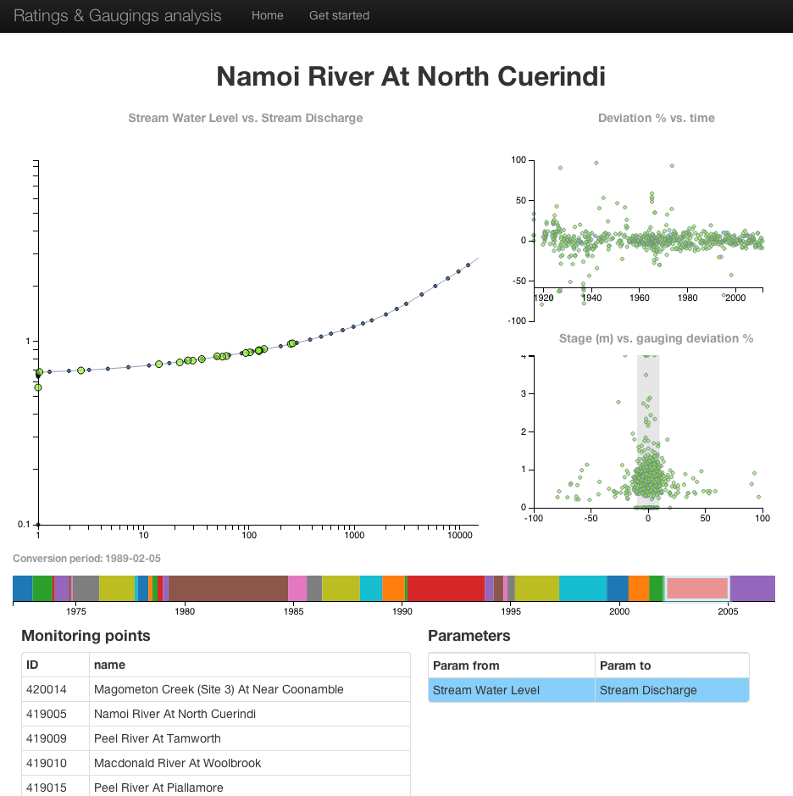
Ratings, gaugings and cross-sections Interoperability Experiment brief
This document gives an overview of a proposed Interoperability Experiment to be run by members of the WMO/OGC Hydrology Domain Working Group (HydroDWG), focusing on exchange of hydrological rating tables.

Acronyms & definitions
WMO – World Meteorological Organisation
OGC – Open Geospatial Consortium
HydroDWG – WMO/OGC Hydrology Domain Working Group
WaterML2.0 part 1 – OGC standard for exchange of hydrological time-series data
WaterML2.0 part 2 – draft OGC standard for exchange of hydrological rating tables, gauging and river cross-sections.

Background
The HydroDWG is focused on the definition of exchange formats and service interfaces to exchange hydrological data in multiple, interoperable ways. The group operates as a community of practice for hydrological data managers looking to share practices and techniques for effective hydrological data exchange. The group starts specific activities for specification of standards and operation of tests for data exchange in particular scenarios.
The OGC operates an interoperability program that offers a number of initiatives to “…develop, evolve, test, demonstrate and validate…” standards. One initiative is Interoperability Experiments that are: “brief, low-overhead, formally structured and approved initiatives led and executed by OGC members to achieve specific technical objectives that further the OGC Technical Baseline.”

Interoperability experiment objective
The process of moving WaterML2 part 2 through to becoming a standard involves testing the draft standard to ensure the needs of the community are being met. An interoperability experiment is the primary method for testing the draft standard. Interoperability experiments implement encoding of the information model across OGC web services to test information exchange. The lessons learnt along the way and findings of the IE are used to further refine and develop the draft standard.

Proposed work
An IE is being proposed by members of the HydroDWG to test exchange of rating tables, gauging observations and river cross-sections. A draft WaterML2.0 part 2 information model is available as a public discussion paper here, the model describes the type of data being exchanged. The discussion paper also outlines exchange use cases and requirements for the information model. A short video of a prototype client for the IE can be seen here, which shows an example of use case 1 detailed below.
The IE is looking at testing the following use cases:
- Public / Researcher data user.
  - An individual is interested in understanding how derived hydrological data, such as river discharge, is generated. There are varying levels of sophistication of users:
    - General public
    - Students of hydrology
    - Researchers investigating inherent uncertainty the conversion process.
- Hydrological data managers
  - A user and/or system want to retrieve the most up to date rating for a particular site.
  - A user and/or system want to retrieve a full family of rating tables for a particular monitoring site.
  - Interoperability between two disparate software systems. Two organisations want to exchange data and are running different underlying hydrological data management systems.

What is expected from participants?
It is expected there will be a number of roles for participants of IE:
- Data holder: you hold a data set that may be of interest from a data exchange perspective. E.g. someone else regularly wants this data; you currently exchange this data; you want to exchange this data.
- Software service provider: you are able to provide software services that will implement prototype web services to encode the sample data.
- Software client provider: you are able to provide a running client that can demonstrate consumption of web services that encode ratings data.
- Infrastructure hosting: you have the ability to host public-facing web services and/or clients.
Any combinations of the above are also obviously valid. We welcome any contributions!

How will the IE be run?
It is likely that the IE will be split according to a number of well-defined scenarios that relate to the use-cases combined with active participants. For example, there will be an Australian-based scenario that captures data exchange of full rating history between a number of Australian water agencies and the Bureau of Meteorology.
The type of role(s) each participant takes on will determine the level of involvement. Participants contributing software will be likely to require more regular contact with the IE than others.
Semi-regular teleconferences will be held to coordinate activities, but these may operate within the sub-groups to minimize time required to participate. We understand that time is precious and in-kind contributions can be difficult; we will endeavor to run the IE with this in mind.

Technical details
In terms of service and client development, the exact details have not yet been defined, as this is part of the planning. But the proposed web-services will need to support the agreed on encoding format, that is likely to be XML and/or JSON, coupled with a web-service operating over HTTP (e.g. WFS/SOS, SOAP, HTTP key-value pairs, RESTful API etc.). Participants are encouraged to provide input on the definition of these formats/interfaces based on the existing work.
The IE will deliver running software that can demonstrate satisfaction of the use cases, along with an engineering report on conclusion of the IE.

What is the timeline?
The proposed high-level dates are as follows:
- September 2013 – IE kickoff
- November 2013 – General design and agreement of schema and services
- November-April 2013 – Iterative development
- May 2014 – Demonstration of IE
- June 2014 - Delivery of draft engineering report

Who to contact
Please send an email to peter.taylor@csiro.au and/or p.sheahan@bom.gov.au if you are interested or have any questions.

