RALFIE: Reduce Potential Radiation Exposure by OGC-based Sensor Information Platforms
Kyoung-Sook Kim, Isao Kojima, Hirotaka Ogawa
National Institute of Advanced Industrial Science and Technology (AIST), JAPAN

Introduction
A significant amount of radioactive materials released into the environment after the nuclear power plant accident in Fukushima. The radiation exposure has brought lots of concerns about environmental contamination, economic, and social consequences. RALFIE (RAdiation Exposure LiFelog Indicator) project aims to assist Fukushima residents to reduce potential health effects of radiation exposure based on life pattern mining. In particular, we are required to support a rapid information feedback loop from the data acquisition to guideline development between residents and experts. In order to achieve the goal, the scope of the project includes the following research and development items:
- Open sensor information platform for moving features: In our use cases, there are two information sources of radiation monitoring data: one is the official data from JAEA (Japan Atomic Energy Agency), and the other is the crowd-sourced data from mobile volunteers in the local area. We have already developed an OGC-based sensor information platform for the legacy archive data from JAEA including periodical surveys by public cars, helicopter and soils, and historical records of monitoring posts/stations. It has provided easy-to-use interfaces based on OGC Web services such as WFS, WMS, SOS, and CSW for data reuse in other applications. However, the platform is recently required to handle real-time monitoring data of mobile volunteers and monitoring sensors equipped on the buses in Fukushima area. Comparing to static locations of monitoring data, the mobile users and buses change their location over time and much frequently report the level of radiation. In the RALFIE project, we extend the current platform to manage and retrieve real-time radiation data from mobile sensors as well as the environmental monitoring data of static stations.
- Personal life-logging system and cloud services: D-Shuttle is a personal dosimeter developed by AIST and Chiyoda Technol Corporation. It was basically designed for long-term operation up to one year without a battery exchange. Consequently it cannot connect other devices, especially smart phones and GPS devices, via the Internet or wireless communication networks. In the project, we develop a prototype of D-Shuttle that is equipped with a wireless communication interface to connect and communicate with the Internet. Based on the communication, we also develop a mobile application and web services in the cloud to monitor personal radiation levels along with GPS locations and activity records over time, manage time series or cross-sections of personal lifelogs, and finally estimate potential radiation exposure by integrating environmental monitoring and personal logging data. The cloud service should support developer-friendly and standard interfaces from the Internet with a secure way. In addition, the service need to filter/deliver the information for/to mobile volunteers and experts with publish and subscribe.
- Statistical and semantic abstraction (summary) of radiation data based on human activities: Because of privacy issues, mobile users are unwilling to share their whole lifelogs; but they want an expert to interpret data and compare with other or average cases. In order to share personal logs with people, we need to abstract data by combining geospatial and statistical information based on personal attributes and activities (e.g., the average level of radiation measurements related to working outside for a month). In particular, it is important to identify a pattern of activity such as `running’, `working’, or `commuting’ from the numerical changing of radiation level in the personal lifelogs. The RALFIE project is concerned with a data model and format for a partial data sharing of the personal lifelog data by transforming (aggregate, filter, and summarize) data with a geo-statistical approach and sematic enrichment.

Use Cases
The standardization of boundary interfaces and APIs is fundamental to implement interoperable and common sensor information platforms and services. In order to develop RALFIE cloud services, we first consider the use cases of service users. There are two types of users: resident volunteers and experts. Figure 1 shows a use case diagram. One of main use cases is to get the notification about contaminated spots in daily activities of volunteers. The service estimates hotspot or outlier areas of exposure measurements in the personal logs, and provides the estimated results to the corresponding users. The personal information is excluded in the notification. In our scenarios, the volunteers can only look into each record of their own logs, but the expert can only look at the summary information of a volunteer who accepts the data sharing. For volunteers, the service offers the capability to store and access log data (e.g., geographical locations and personal sensor measurements) anytime and anywhere. In addition, the experts sometime want to import other statistical data to compare the average cases with the log summaries. If the expert found a high potential of health effects of radiation exposure, he/she publish a reference guide to reduce the amount of potential exposure. The volunteers can get the notification for the guidance if only it matches their situation. Finally, they can send a direct message to the guidance provider when they want to ask more.
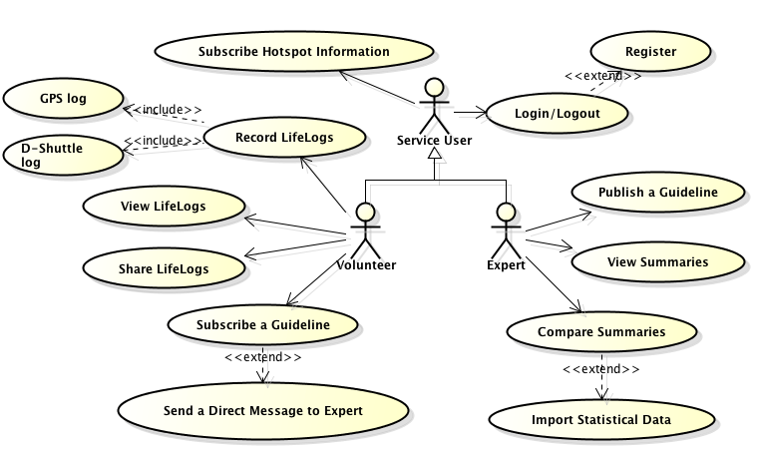
Fig 1. RALFIE service users

Related OGC Standards and non-OGC standards
OGC standards: CSW, WFS(-T), WPS, TJS, Moving Features, (SensorThings API)
Non-OGC standards: SDMX(-HD), W3C Data Cube Vocabulary, OData, JSON (GeoJSON/JSON-STAT/JSON-LD)

http://www.c-technol.co.jp/eng/e-dshuttle

